GIT GITHUB
Checking git version, initialising git, viewing .git file structure and git status command.
git –version
git init
git status

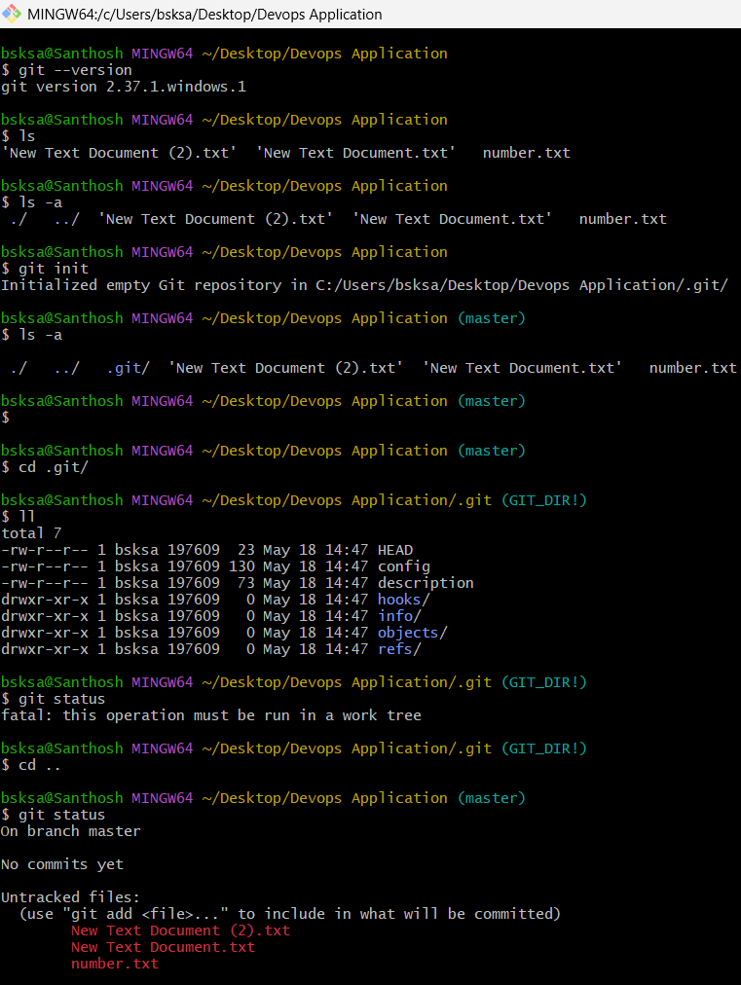

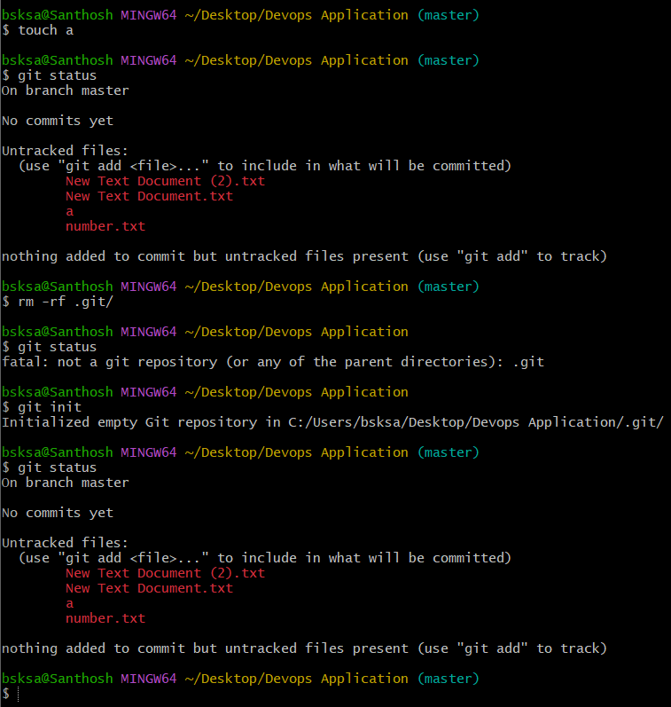

Configure username and user email
git config –global user.name “krishnasanthosh6160”
git config –global user.email krishnasanthosh6160@outlook.com

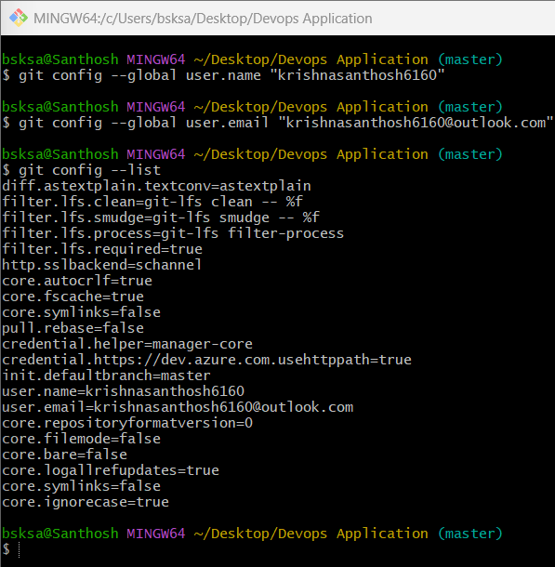

Moving the files from untracking to tracking area using “git add filename” command.
For adding many files at a time to tracking area use “git add .”
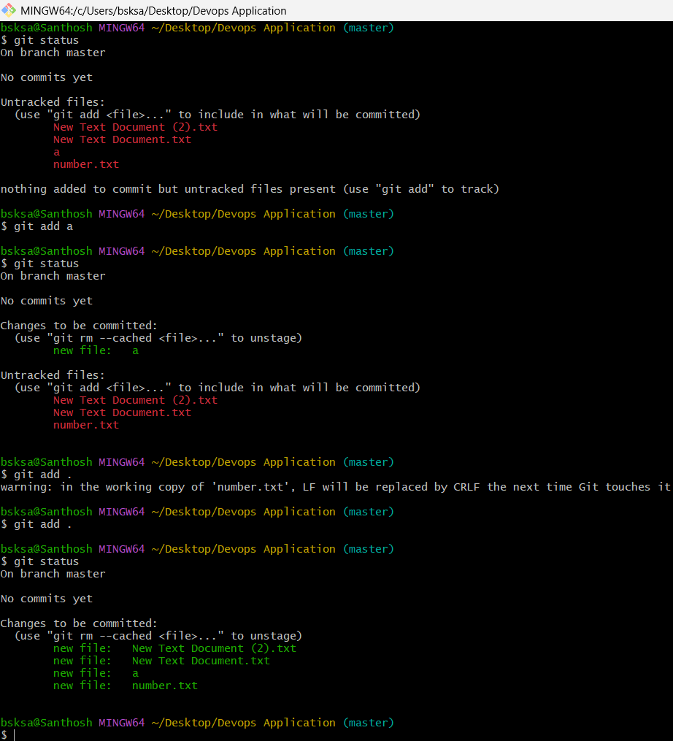

Git commit command is used to commit the changes.
git commit -m “message”

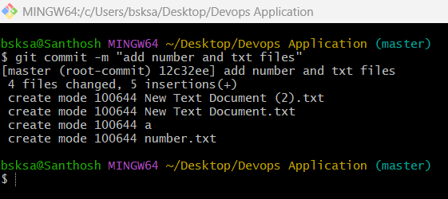

git log command is used to display all the logs or all the commits

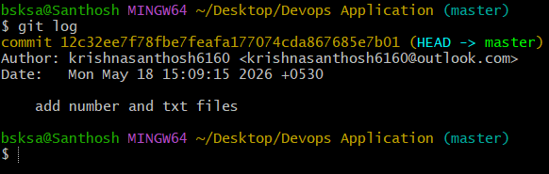

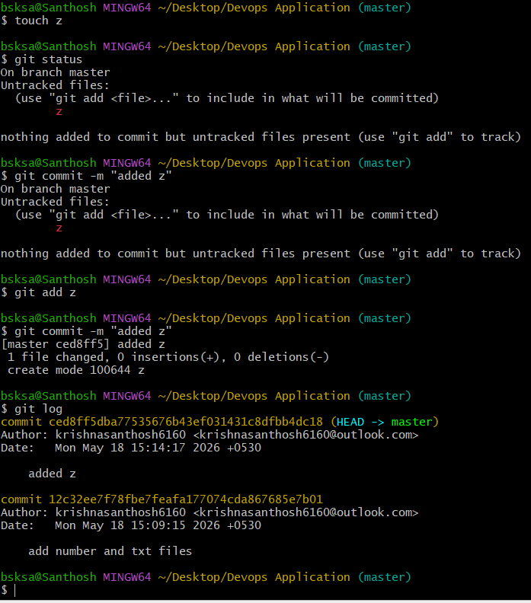

git remote add origin git@github.com:krishnasanthosh6160/git-github.git
git remote -v

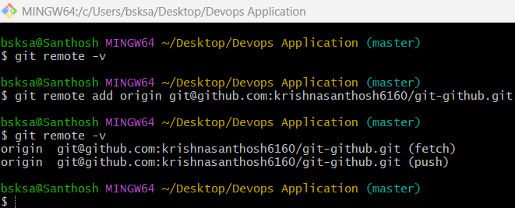

Git connectivity from local machine to git repository
Generate rsa key using ssh-keygen command in local machine
Copy the path where the rsa.pub key is generated
On terminal mention “cat pathname/rsa.pub”
Copy the ssh key and navigate to github settings menu
Enter SSH and GPG keys section
Click on New SSH key
Name the title and paste the copied rsa.pub key

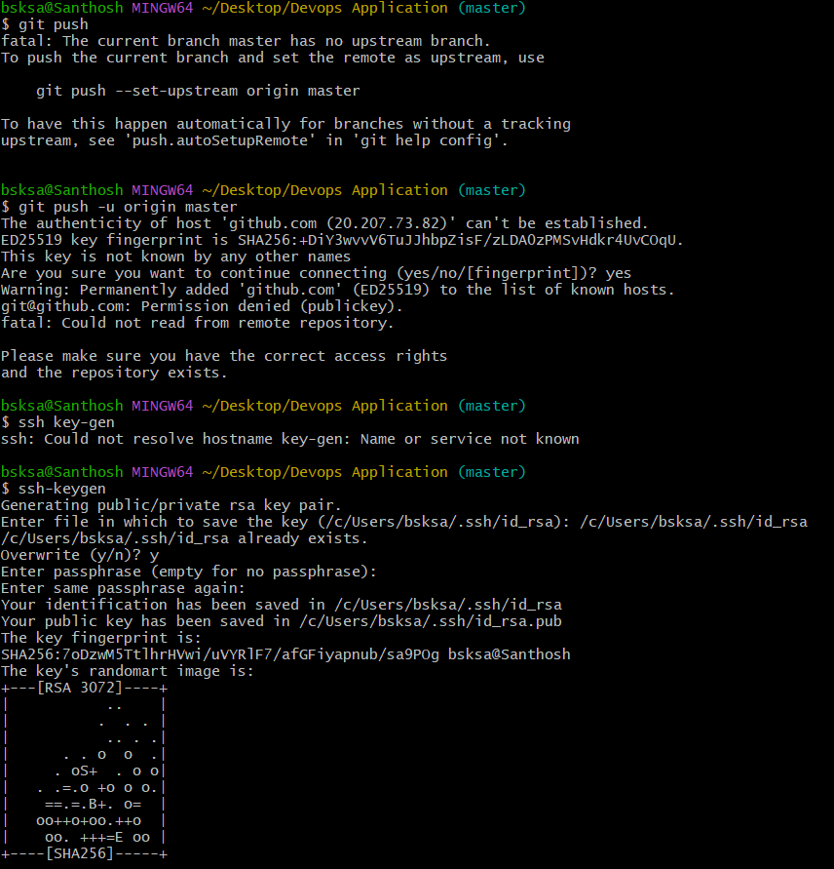
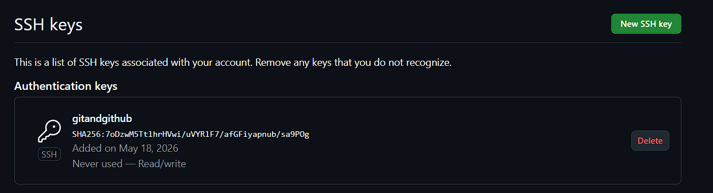

Now, switch to gitbash terminal,
Enter command “git push -u origin master”
Origin is remote destination
Master is branch name.

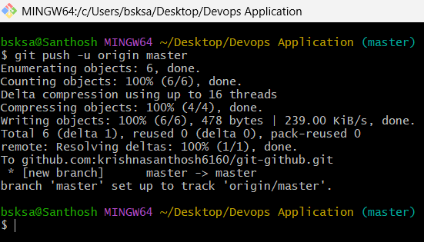

Go to created repository in github website account.

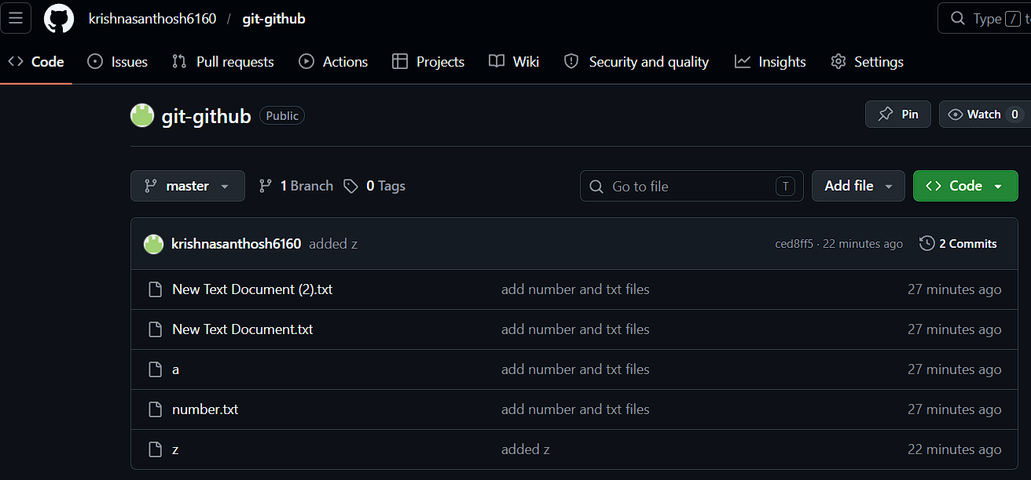

Github repository link: https://github.com/krishnasanthosh6160/git-github.git
Deleting a file in local system

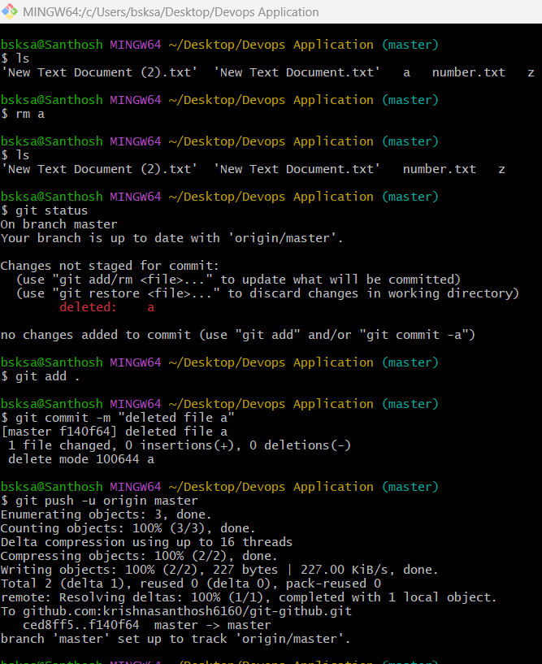

The changes or synchronization to repository will happen with respect to location, upon deleting a file from local machine and track, commit and push to repository.
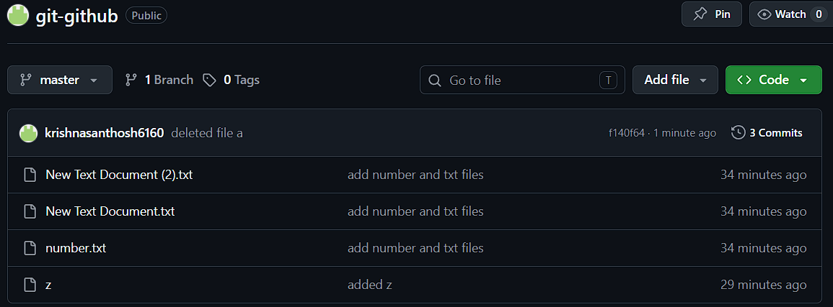

Changes made in the central repository.
Create a file on github repository from github website.
There is no file in the local machine which is created in github repository directly on site.
Navigate to gitbash and check with ls command
Notice that the file is not visible.

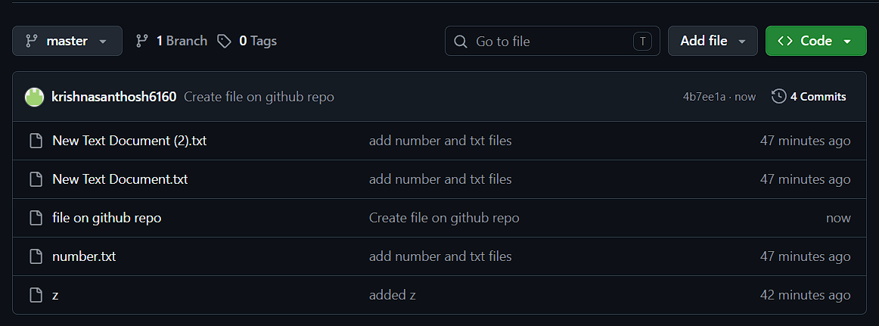

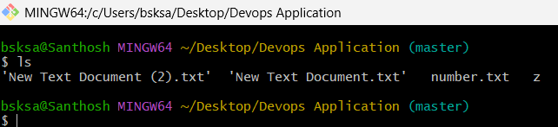

From local machine create a file and try to push into repository
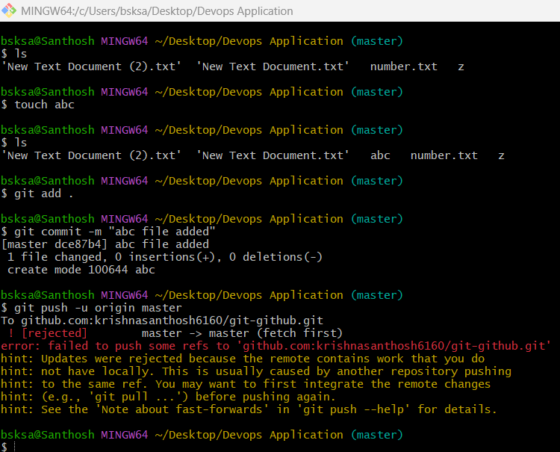

Notice that the push is failed due to
$ git push -u origin master
To github.com:krishnasanthosh6160/git-github.git
! [rejected] master -> master (fetch first)
error: failed to push some refs to 'github.com:krishnasanthosh6160/git-github.git'
hint: Updates were rejected because the remote contains work that you do
hint: not have locally. This is usually caused by another repository pushing
hint: to the same ref. You may want to first integrate the remote changes
hint: (e.g., 'git pull ...') before pushing again.
hint: See the 'Note about fast-forwards' in 'git push --help' for details.

So, the above error happened due to the data or file in local and repository are not same or not synchronized.
Hence using git pull command the data or files in repository are copied to local machine.
Then using ls command notice that the new file is listed in the directory.
Now, git push -u origin master command works without any issue and file is pushed to central repository.
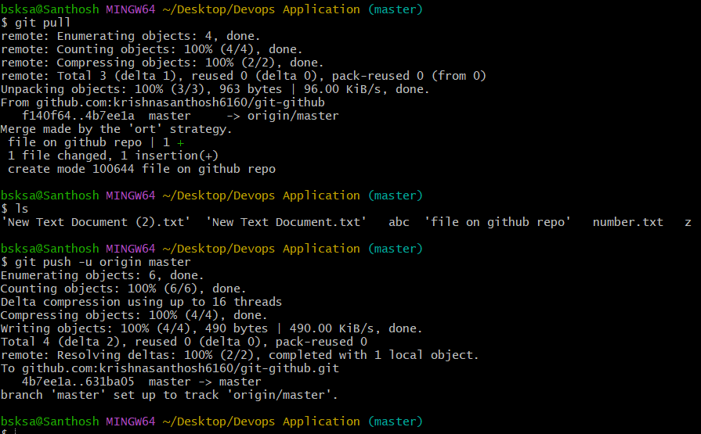

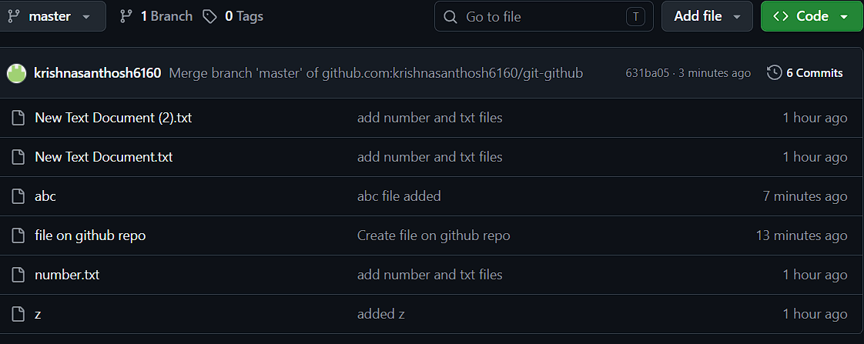

Cloning the repository to local machine.
It is used download complete repository.
git clone repository url
git clone git@github.com:krishnasanthosh6160/git-github.git
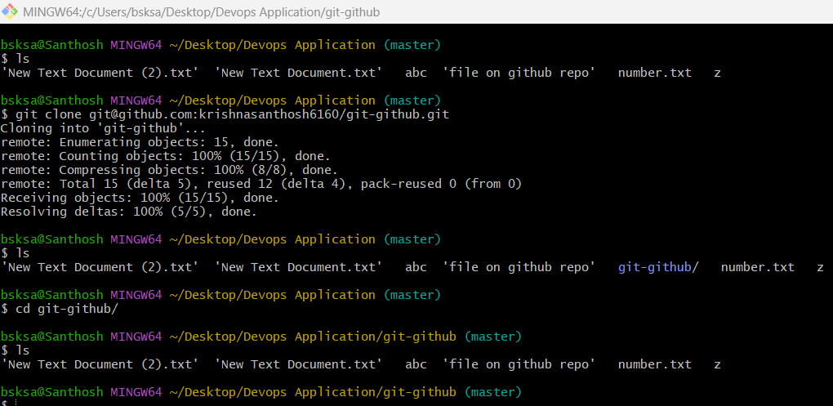

git revert <commit_id>
User can revert changes using the git revert commit id command.
We can get the commit id using command git log.

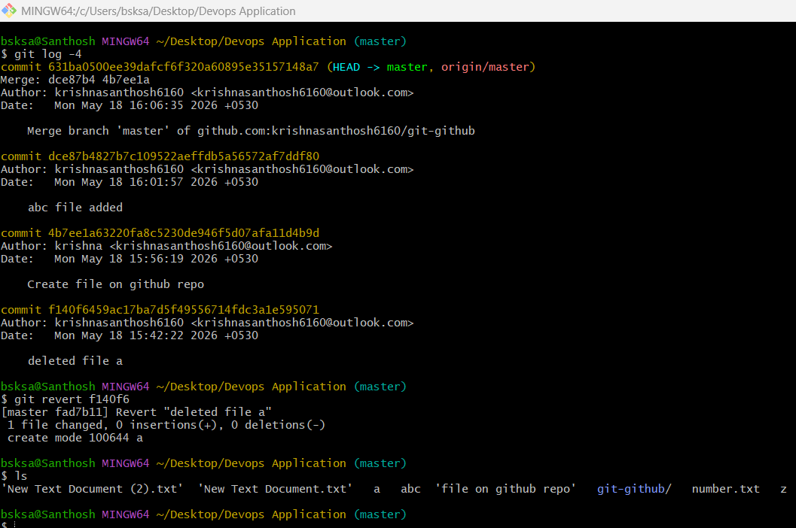

Git reset

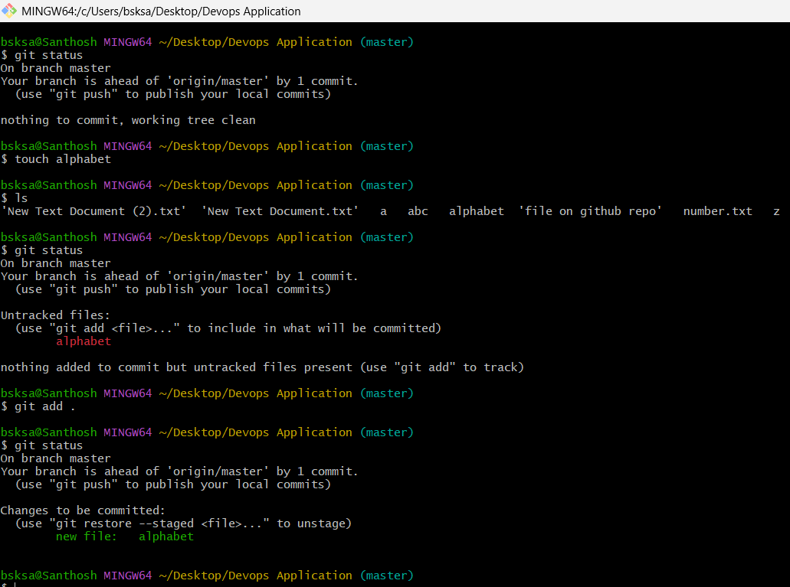

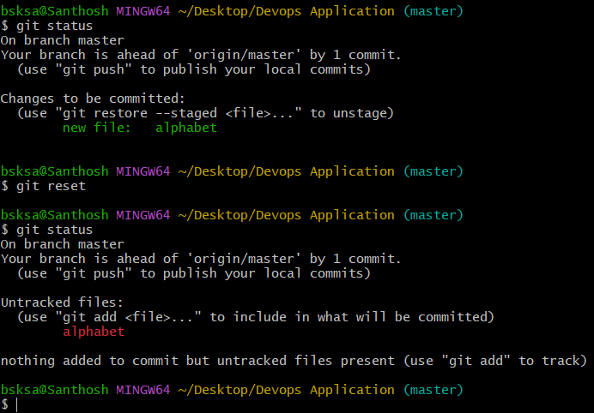

Fork usage:
Using fork option, we can directly copy others repository to our repository and also can make the required changes as per our convenience.
Or using git clone command with the repository url we can directly download it to our local machine.

